# University of Toronto Students: Academic vs Social Life

Low-Fidelity Prototype

Unique Corns

CSC318H1

Fanny Chevalier and Khai Truong

### 

Parth Champaneri, Allen Hsiao, Clare Kim, Pascal Queeney, Patrick Tan

Monday, November 5th 2018

# **Table of Contents**

**University of Toronto Students: Academic vs Social Life**

**Table of Contents** **1**

Summary 2

Design Alternatives 3

Hotspots 3

Pros and Cons 3

Informal Feedback 4

Website/Mobile App 6

Pros and Cons 6

Informal Feedback 7

Extension: Quercus 8

Pros and Cons 8

Informal Feedback 9

Paper Prototype 10

Home and Finder 11

Advantages and Disadvantages 12

Threads and Detailed Event 13

Advantages and Disadvantages 14

Create-an-Event 15

Advantages and Disadvantages 15

Profile 16

Advantages and Disadvantages 16

Storyboard 17

Low-Fidelity Prototype - Evaluations 20

Heuristic Evaluations 20

Lessons learned and implications for designs 23

Usability Testing Recordings 24

Notes 25

Group Management 25

## **Summary**

In the second process of the design cycle, we brainstormed many ideas to map out our potential solution. In this paper, we look to expand on the best ideas from the brainstorm and sketch them as potential solutions. Within each sketch, we looked into the different advantages and disadvantages, and also analyzed the informal feedback that was presented in studio 4. From this information, we created our potential solution by combining the best features from each individual idea. Then we look at creating the paper prototype, and explaining key functionality concepts that we aim to implement in the high-fidelity. After understanding what our solution will do, we created a storyboard section, explaining different tasks which the user will use our product for. Finally, we tested our prototype in studio 5, and explain the biggest takeaways we learned whilst conducting the usability testing. Then to conclude the paper, we look at what can we bring forward from our testing, and how will we implement and change certain design features to make our high-fidelity prototype a success.

## **Design Alternatives**

### **Hotspots**

Hotspots is a more traditional look on connecting students within the University campus. The main idea of Hotspots is the name, around campus major buildings will be pinned as a hotspot and certain events will always be hosted in the area. For example, Robarts can be a hotspot for events like Facilitated Study Groups, or Academic Workshops. The main idea is that students will be able to walk past these hotspots on the way to class, or simply to use the library, and they can see which events are happening throughout the day and can drop in/out at any time. Hotspots can be flexible to various range of activities, like pick-up sports (gym hotspot), movies (theatre hotspot), cards and board games (cafe hotspot). On the same note, hotspots allow the university to promote their various programs because certain events will be based on specific buildings. As an example, computer science events will generally be held in Bahen. This allows students to explore different programs within the university and find new interest based on the hotspot. Hotspots around campus encourages the students to attend drop-in activities, without the idea of committing to it weekly.

#### **Pros and Cons**

|  |  |
| --- | --- |
| **Pros** | **Description** |
| Encourages drop-in activities without prior commitment | The nature of hotspots, allows students to walk by these areas and check if the particular event interest them. No need to sign up, just a simple drop-in/out system |
| Encourages communal areas within the campus | Since hotspots will utilize the various buildings on campus, this will grow different student hubs in these buildings because of the consistent attendance of students |
| Physical schedule could make finding events more fun | The idea of having to walk to the hotspot and see what is happening and who is there could be fun for students. It is more interactive way, rather than searching through a list of events. |

#### 

|  |  |
| --- | --- |
| **Cons** | **Description** |
| Hotspots will not always be accessible or usable at times | Events would have to work around buildings and area’s operation hours. Not every building will be able to host events throughout the day, buildings will also host their own events |
| Cater towards popular hobbies amongst students vs niche hobbies | Since hotspots are hosted through different buildings or areas, it will be bias towards certain hobbies. It will be hard to accustom niche hobbies like rollerblading or poetry, things that aren’t as popular in student bodies because what building or area could they host in |
| Can’t plan to go to events in advance - have to walk by the building or be in the area to know event schedule | Finding events is not widespread, through digital means. To find events you would have to be in the area or building at the time, to learn about what is happening throughout the day |

#### **Informal Feedback**

The main feedback that was given for this particular idea was how will it accompany the different types of hobbies and interest. As noted earlier in the advantages and disadvantages, hotspots would be biased towards certain hobbies and events. Hotspots would generally encourage popular events amongst students, rather than niche hobbies. For instance, someone who wanted to attend a skateboarding event. There is really no particular building or area on campus that would be an appropriate hotspot for that hobby. So, hotspots are generally bias towards events that are common among the student population like drop-in sports or study groups.

It was also noted that hotspots are pretty static, in terms of finding what event is happening at the building at the time. It was told that it would be hard for students to plan out what events they would like to attend, if they had to go to each hotspot separately and see what event is happening. From this, a couple questions were raised, asking what happens if their event is not being hosted that day? Would students have to keep waiting until it is next hosted? The biggest takeaway from these questions are, how will this idea of hotspots become a more efficient process in finding and joining events.

### **Website/Mobile App**

The website and mobile application would be focused on creating and joining events on the university’s campus. The application will utilize the geolocation function within both mobile and websites, so it can find events based off the current location. The map offers event pins, where users can drop pins and host quick events. From the map users will be able to peek and join the events. The application will also have a reward system upon joining different events or hosting. The system is based off badges, encouraging users to collect all the different badges to display on their profile. Then finally the application will let you find different classmates that are attending the event. Letting students choose events based on if their friends are attending, which helps ease the transition into a better social life.

#### **Pros and Cons**

|  |  |
| --- | --- |
| **Pros** | **Description** |
| Website and Mobile applications offer more design freedom, whilst developing | Creating the application groundup allows a lot more flexibility in terms of design. Being that you are not working off another product. You have more freedom in how you want it to look like |
| Both mobile and website applications are a lot more portable and can be accessed from anywhere | Generally speaking, it can be assumed most students will have access to websites or mobile applications. |
| Mobile and website application can be assumed to be the most used technology between university students | Continuing on from the description above, most students have at least a smartphone. A service that utilizes both mobile and web will mainstream events, making events become more widespread and easier to share. It is the easiest way to create a platform to connect students across campus |

#### 

|  |  |
| --- | --- |
| **Cons** | **Description** |
| Generating a user base | Like most application startups, getting a user base to kick start the application can be hard to obtain. Especially since traditional methods like Facebook Events, or Meetup/Eventbrite exist |
| Website and Mobile applications are both expensive projects | Again, like most startups, these projects can be expensive and require a lot of resources. |
| Development can take a long time | Creating the application can take a long time to develop, which grows the risk of competitors |

#### **Informal Feedback**

The important feedback that was received on this idea was how will we be able to differentiate our application from current products like Facebook Events, Meetup, and Eventbrite. These are services that have been around and commonly used for a few years now. We were told that we should focus on making our solution different than the alternatives, find what they do well but also more importantly what is done bad. Look to refine these issues and create a new improved system.

On another note, the feedback suggested we look into importing students calendars through ACORN to help create their own schedule. The application was only to serve as a way to find events and join events on campus. It was noted that being able to see their schedule whilst planning events will help organize their day/week or month. This will help strengthen the idea of balancing both academic and social life - being able to see where the conflicts in school and social events occur and plan ahead accordingly.

### **Extension: Quercus**

The Quercus extension, or plugin would allow students to be able to browse events within a Quercus “Events” page. The implementation would be a plugin that would be added to Quercus letting users be able to host and join events of their particular interest. The events tab on Quercus, will redirect the student to a events hub, where students will be able to find all upcoming events through a set time. Given the hub is built within Quercus, students will be able to see other classmates attending events and decide whether the event interests them. Upon choosing events, Quercus will be able to detect if certain events conflict with upcoming classes or assignments, and warn students about the conflict.

#### **Pros and Cons**

|  |  |
| --- | --- |
| **Pros** | **Description** |
| Ability to access courses stored on Quercus | To improve the organization of students of balancing social and academics. Quercus being able to know courses will able to filter or warn of upcoming conflicts with particular events |
| Ability to access schedule stored on Quercus | To improve the organization of students of balancing social and academics. Quercus being able to know class schedule will able to filter or warn of upcoming conflicts with particular events |
| Every University of Toronto student has a Quercus account | Every registered student will have a Quercus account upon attending the school. Likewise with ACORN |
| Pre-existing Mobile application | Quercus (Canvas) already has a built mobile application, which allows for more widespread usage. Meaning events can be easily shared throughout campus. |

#### 

|  |  |
| --- | --- |
| **Cons** | **Description** |
| Student’s Privacy | Students may only want quercus to know about their academics. Adding events could potentially add conflict with privacy, and questions about how much will data events will know from the students who join |
| Restricted design | Building through Quercus means there is not much freedom in design options. |
| Too many features within Quercus | Quercus is predominately for academic organization, adding a events feature can be complicated and confusing. Making Quercus do two different things. |

#### **Informal Feedback**

In the real world setting, this can be hard to implement. We would have to gain permission from Canvas (Quercus) to implement our event’s plugin, and this can be a hard process to sell to a company. Since the main idea of extending off Quercus was to implement student schedules and assignments, not all classes utilize quercus. For example, a lot of computer science courses have their own class website (mcs) and assignment pages (markUs). With that said, it was suggested that we utilize ACORN’s import schedule (.ICS file) and create-own-schedule function. So users have full control over their schedule and can account for different classes.

## **Paper Prototype**

For the paper prototype, we took the feedback and considerations and refined them to create a potential solution. The paper prototype is based on a mobile application, that could also be adapted to a website application. The key features we combined are the “map view”, “schedule import”, “calendar view”, and “badge system”. We combined and refined these ideas, to create our idea of a mobile application that can help connect students to different events around campus.

An important idea that our product uses is “Threads”. We decided to name topics and clubs Threads because it is a more casual approach to joining events. The idea of threads is you subscribe to different threads (#compsci, #videogames), and you will be able to see the list of events within that thread. Unlike Facebook Events, sometimes you have to join clubs to find events, or join a club to go to an event. Our motivation of threads is to remove the commitment, and just follow the threads you desire. Sometimes when you join a club, you feel obligated to go to every event but with Threads you just follow what events are coming. Like Reddit’s implementation of threads, users would follow them and become updated when there is news.

*Note: Original size images can be found within the Notes section at the bottom of the PDF.*

## 

### **Home and Finder**

## 

Upon logging in or signing up, the user will move to the homescreen (My Calendar). This view will show upcoming events, and my events. Where ‘my events’ are events that the user created and hosted. These events will dynamically update, whenever users add or remove events. From each view you can navigate with the sidebar menu (accessed from the top left). In the top right, the user can import their schedule via an .ICS file, that can be obtained from ACORN.

Moving to the Find view, you will be presented with a map based on current geolocation. Pins, which represent different events will be displayed based on their hosting location. You can tap pins and peek into them, to see a quick details about the event. From this view, you can switch to a traditional list-view, located at the top right, and events will be shown in a list format. Located in the top left of the map view, you are able to create an event, which would switch to the create-an-event view. In both finder views, you will be able to search different threads, and see particular events within that thread.

#### **Advantages and Disadvantages**

The sidebar is the applications best feature in terms of navigation. You will be able to move from view to view, from any part of the app. Map will be default view on finding events, so in technical terms it will have to use geolocation. This can be costly in terms of data and also could cause privacy issues for students.

### 

### **Threads and Detailed Event**

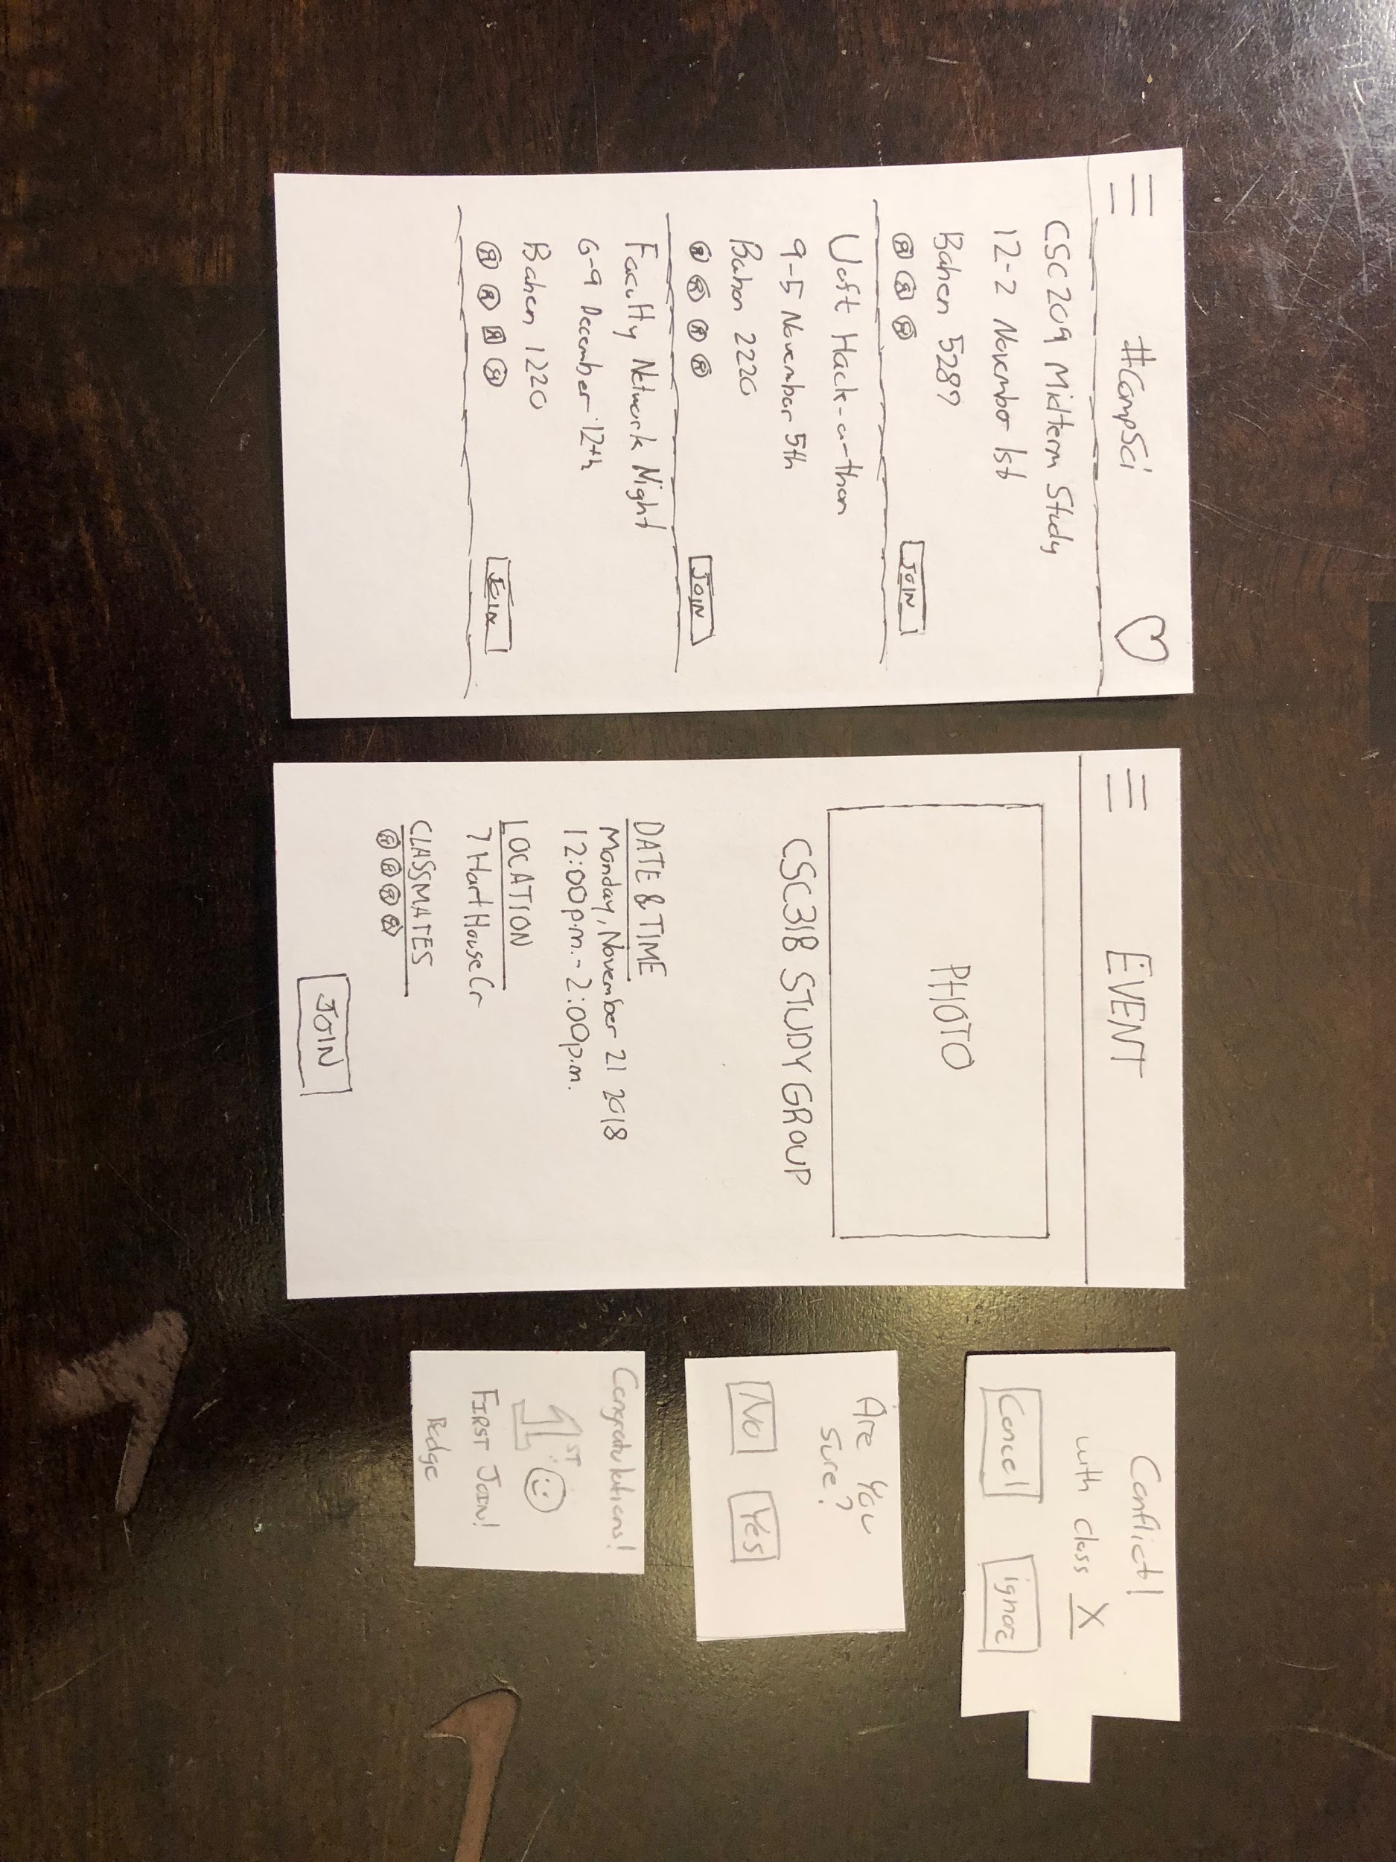

This view is accessed when the user searches for a thread, and clicks on a particular event. In the top right of the thread view, you will be able to favourite/subscribe to the thread. You will be able to follow and view future events that are posted to the thread. It will also be displayed in the user profile of favourited threads. In both views upon clicking join, if there is a given conflict with the user’s schedule a warning will be displayed. Allowing them to either cancel their join or ignore the warning, if the user chooses to ignore a confirmation prompt is displayed. Also, if the user joins an event, the user will be granted a badge (In this case first event!) which will be alerted and then displayed on the user’s profile.

#### **Advantages and Disadvantages**

The key feature of joining events and a conflict warning showing is what helps differentiates the application from pre existing services. This allows users to organize ahead of time, and balance both academic and social life. The badge implementation will help entice users to keep being active on the service, aiming to reach unique badges to show off on their profile. Listed view could be a victim of spam, and could potentially ruin peoples experiences. If the users has to keep scrolling through numerous unwanted events, this could be troublesome.

### **Create-an-Event**

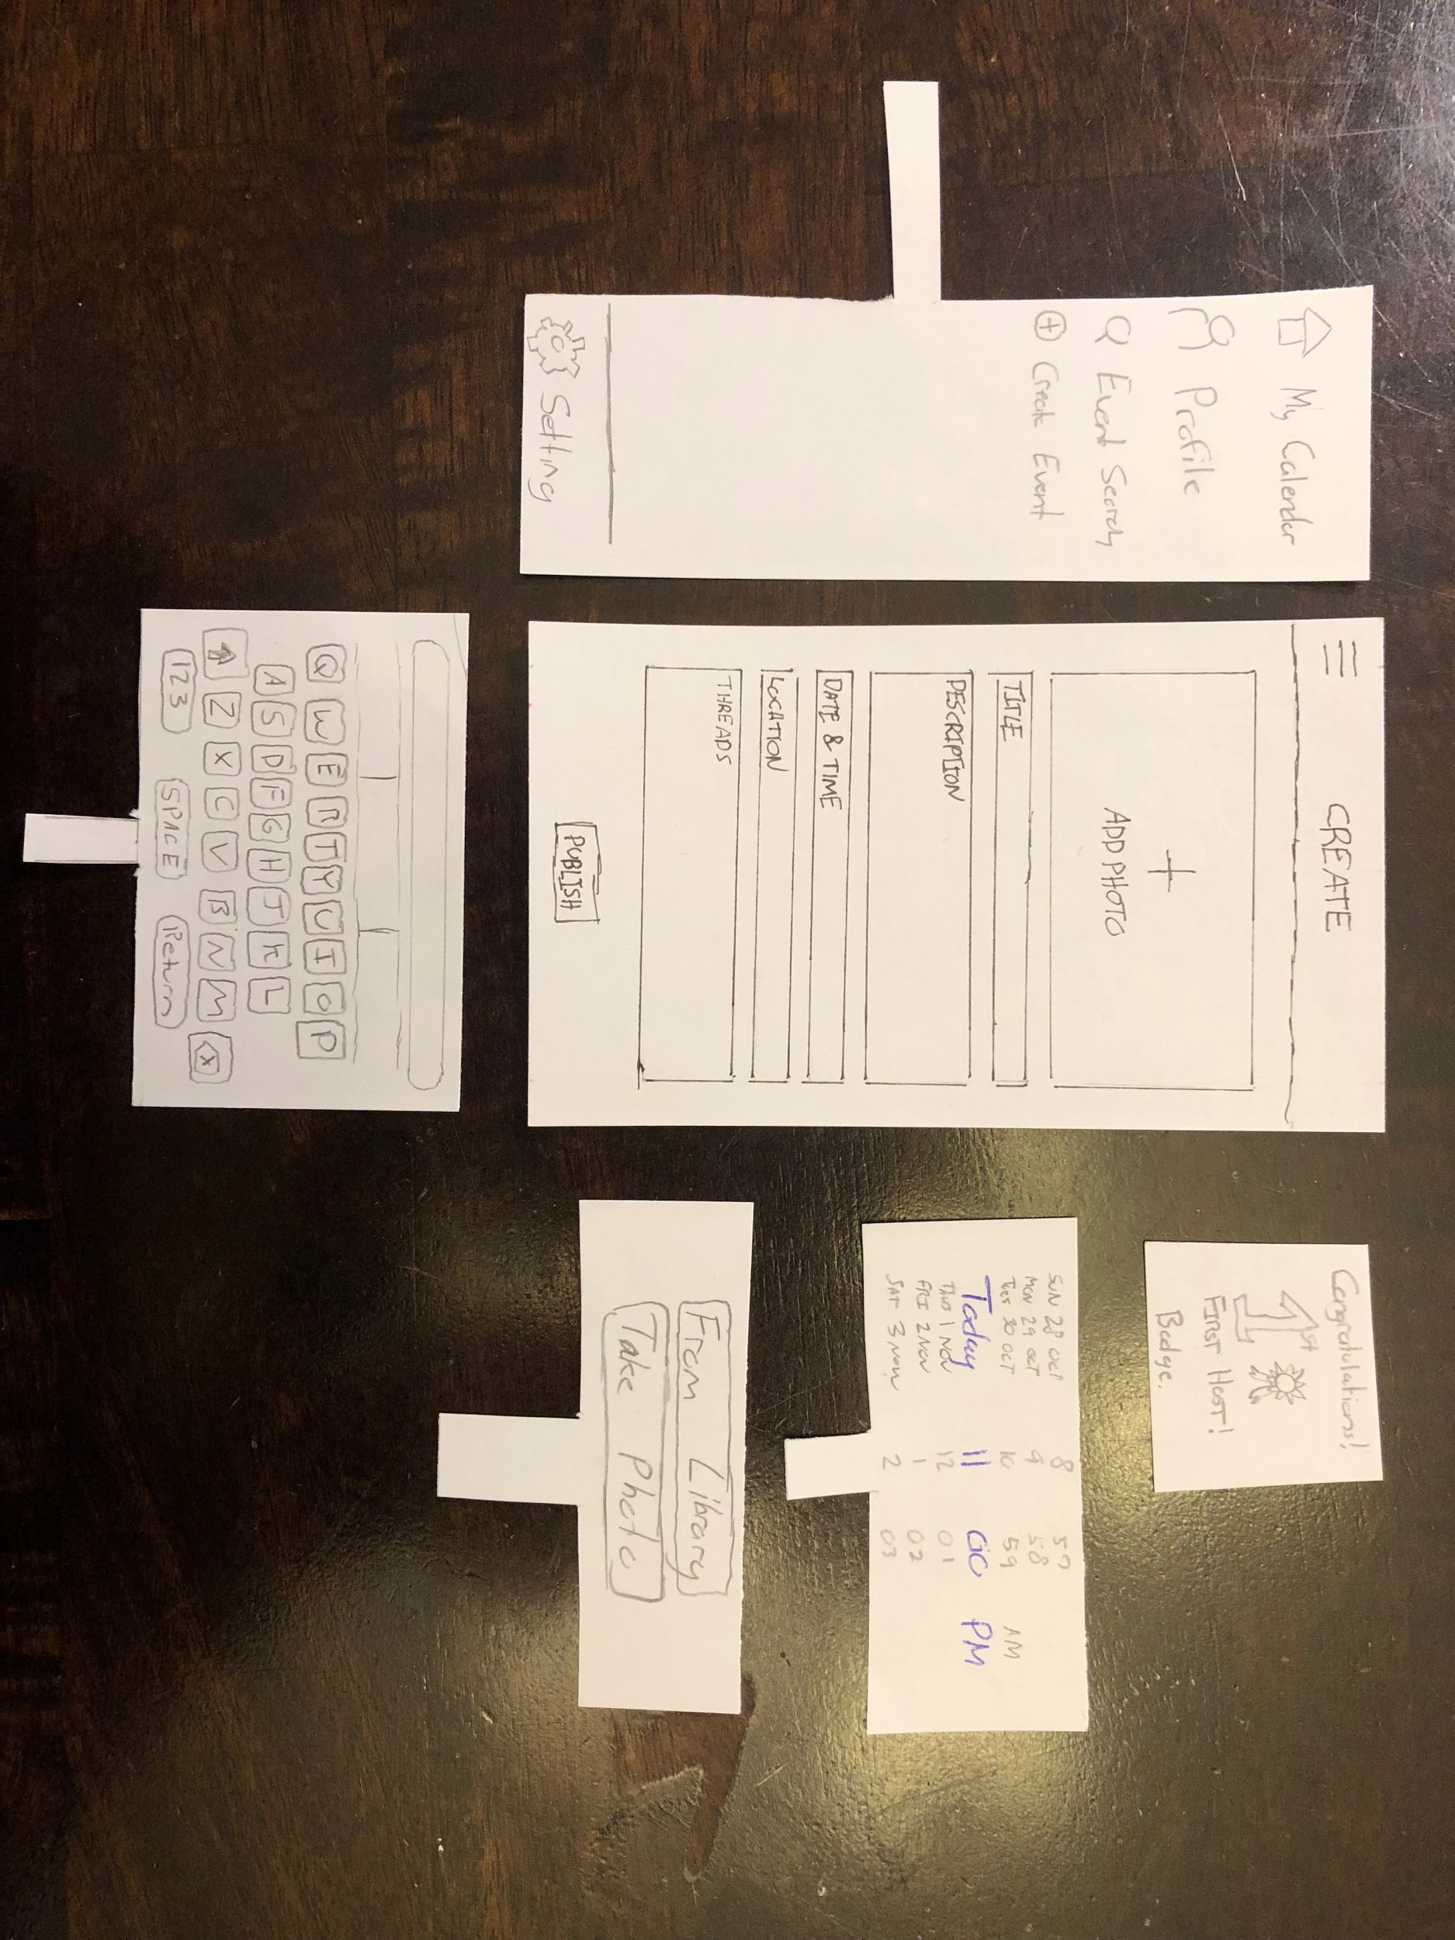

Create view can be accessed through the sidebar menu or plus icon through map view. Functionality in this view is straightforward and should be intuitive to the average user. The user would fill in each data point, and selected prompts will show up based on which data is being manipulated. After publishing, a badge is either displayed (In this case first host!) or an error warning, displaying the particular error whilst publishing.

#### **Advantages and Disadvantages**

The biggest disadvantage in this design is the general assumption every student will know what each data field means. A help button to help list out definitions or explain, will make the process more intuitive for all users - without assuming.

### **Profile**

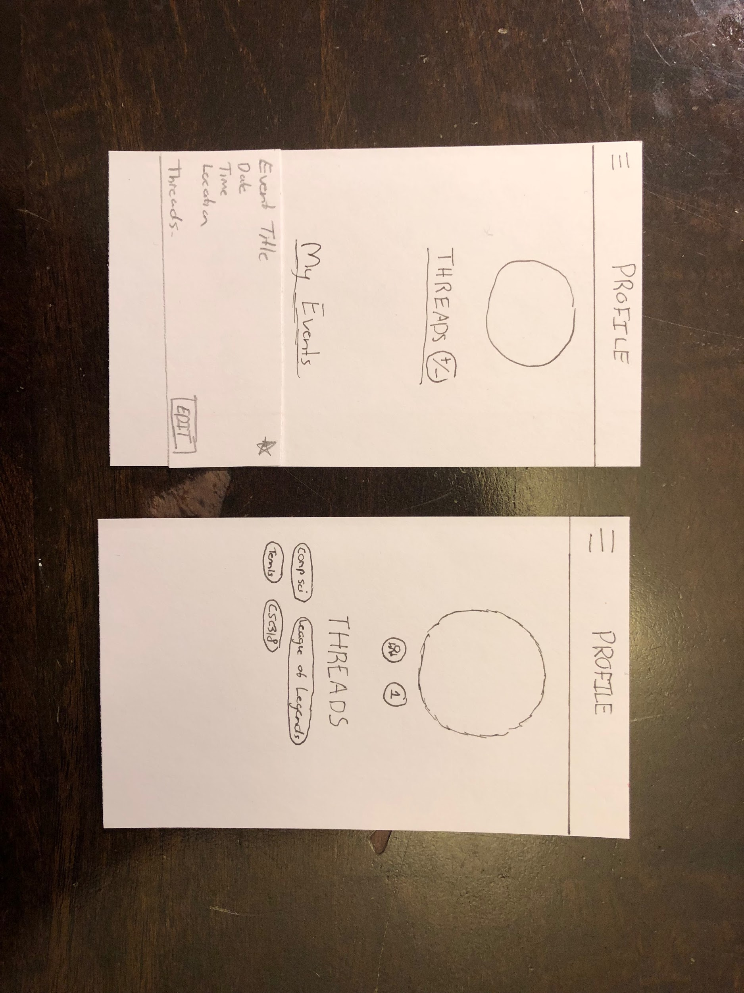

Profile may be accessed through the sidebar menu, and in the quick event details through the classmates preview. On the profile view, you can subscribe and manage threads, by clicking the plus/minus icon. If the user obtained any badges, they will be displayed just under the user’s profile picture. The owner of the profile will be able to see “My Events” which is a list view of the events they are hosting (Indicated by the star - top right corner).

#### **Advantages and Disadvantages**

Biggest drawback with profiles would be that it’s boring and not exciting. Because we are not trying to create a social media platform but a hub of events, profiles are really only used to display badges. Although we believe badges help user behaviour in applications (various studies on this) it still leaves the profile page empty, which could seem unappealing to the user.

## **Storyboard**

*Note: Original size images can be found within the Notes section at the bottom of the PDF.*

**User can find events via attending classmates**

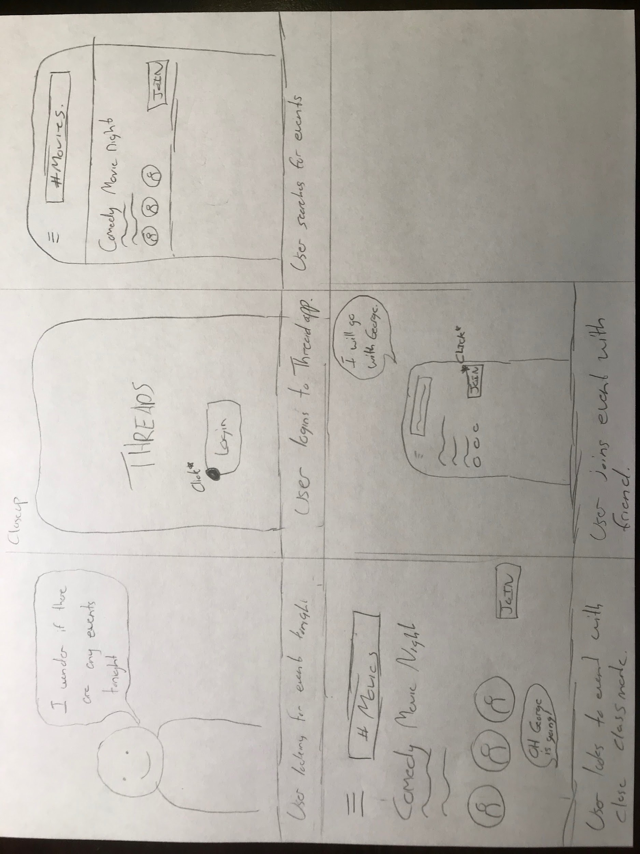

**User has select control over privacy/permission features**

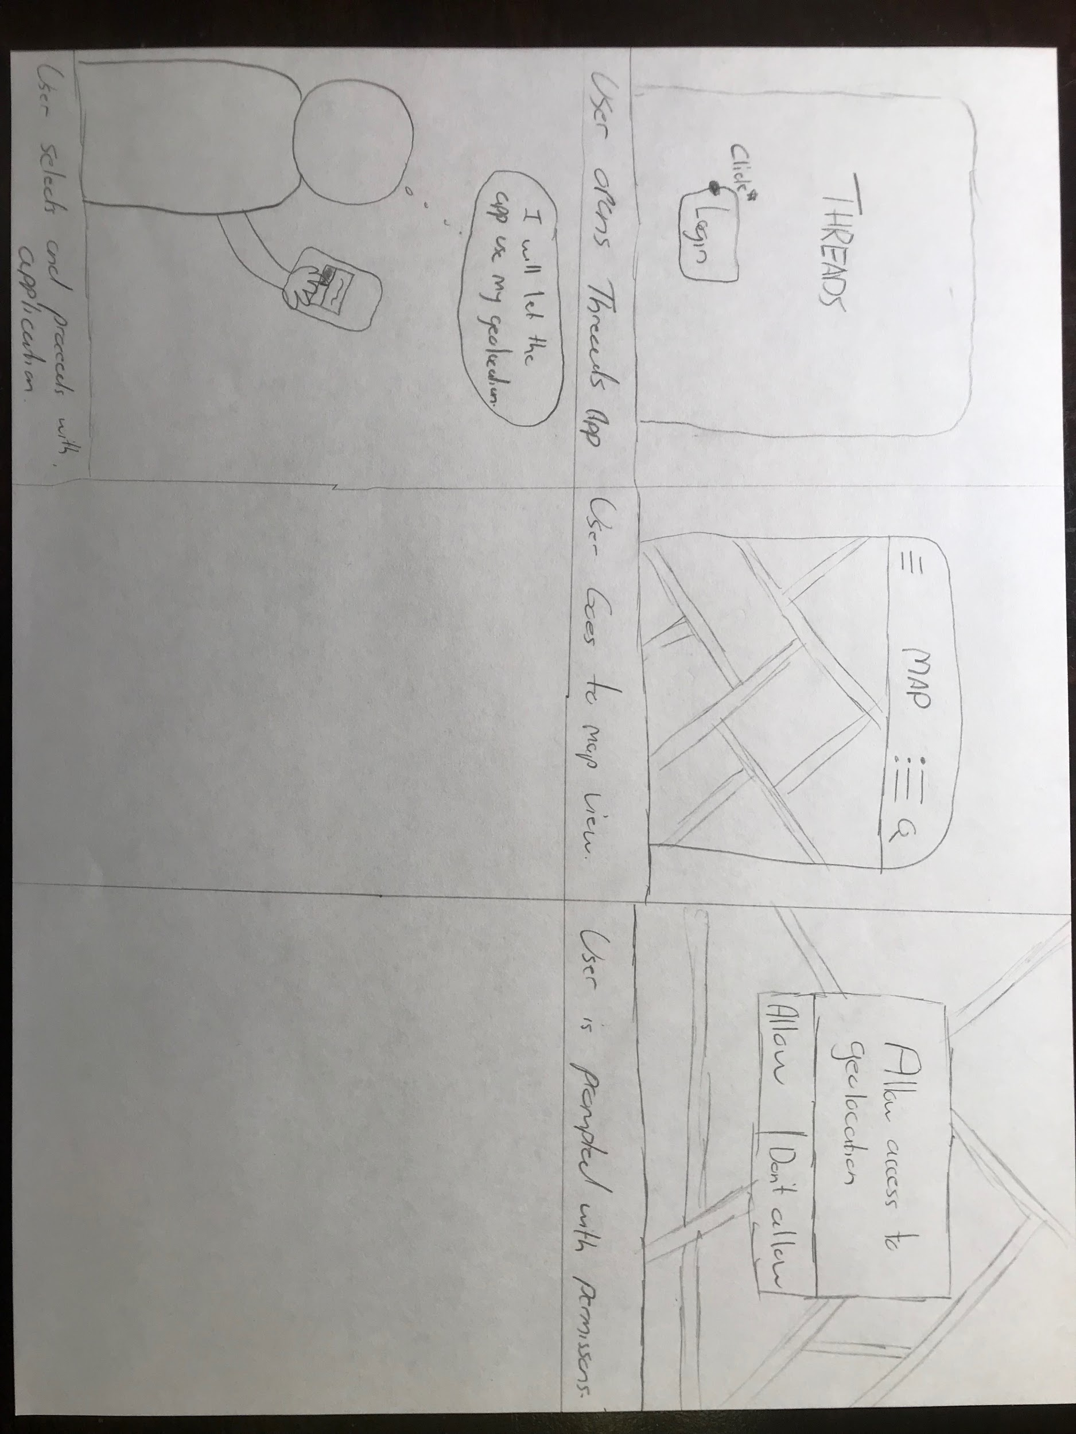

**Application is designed for every student**

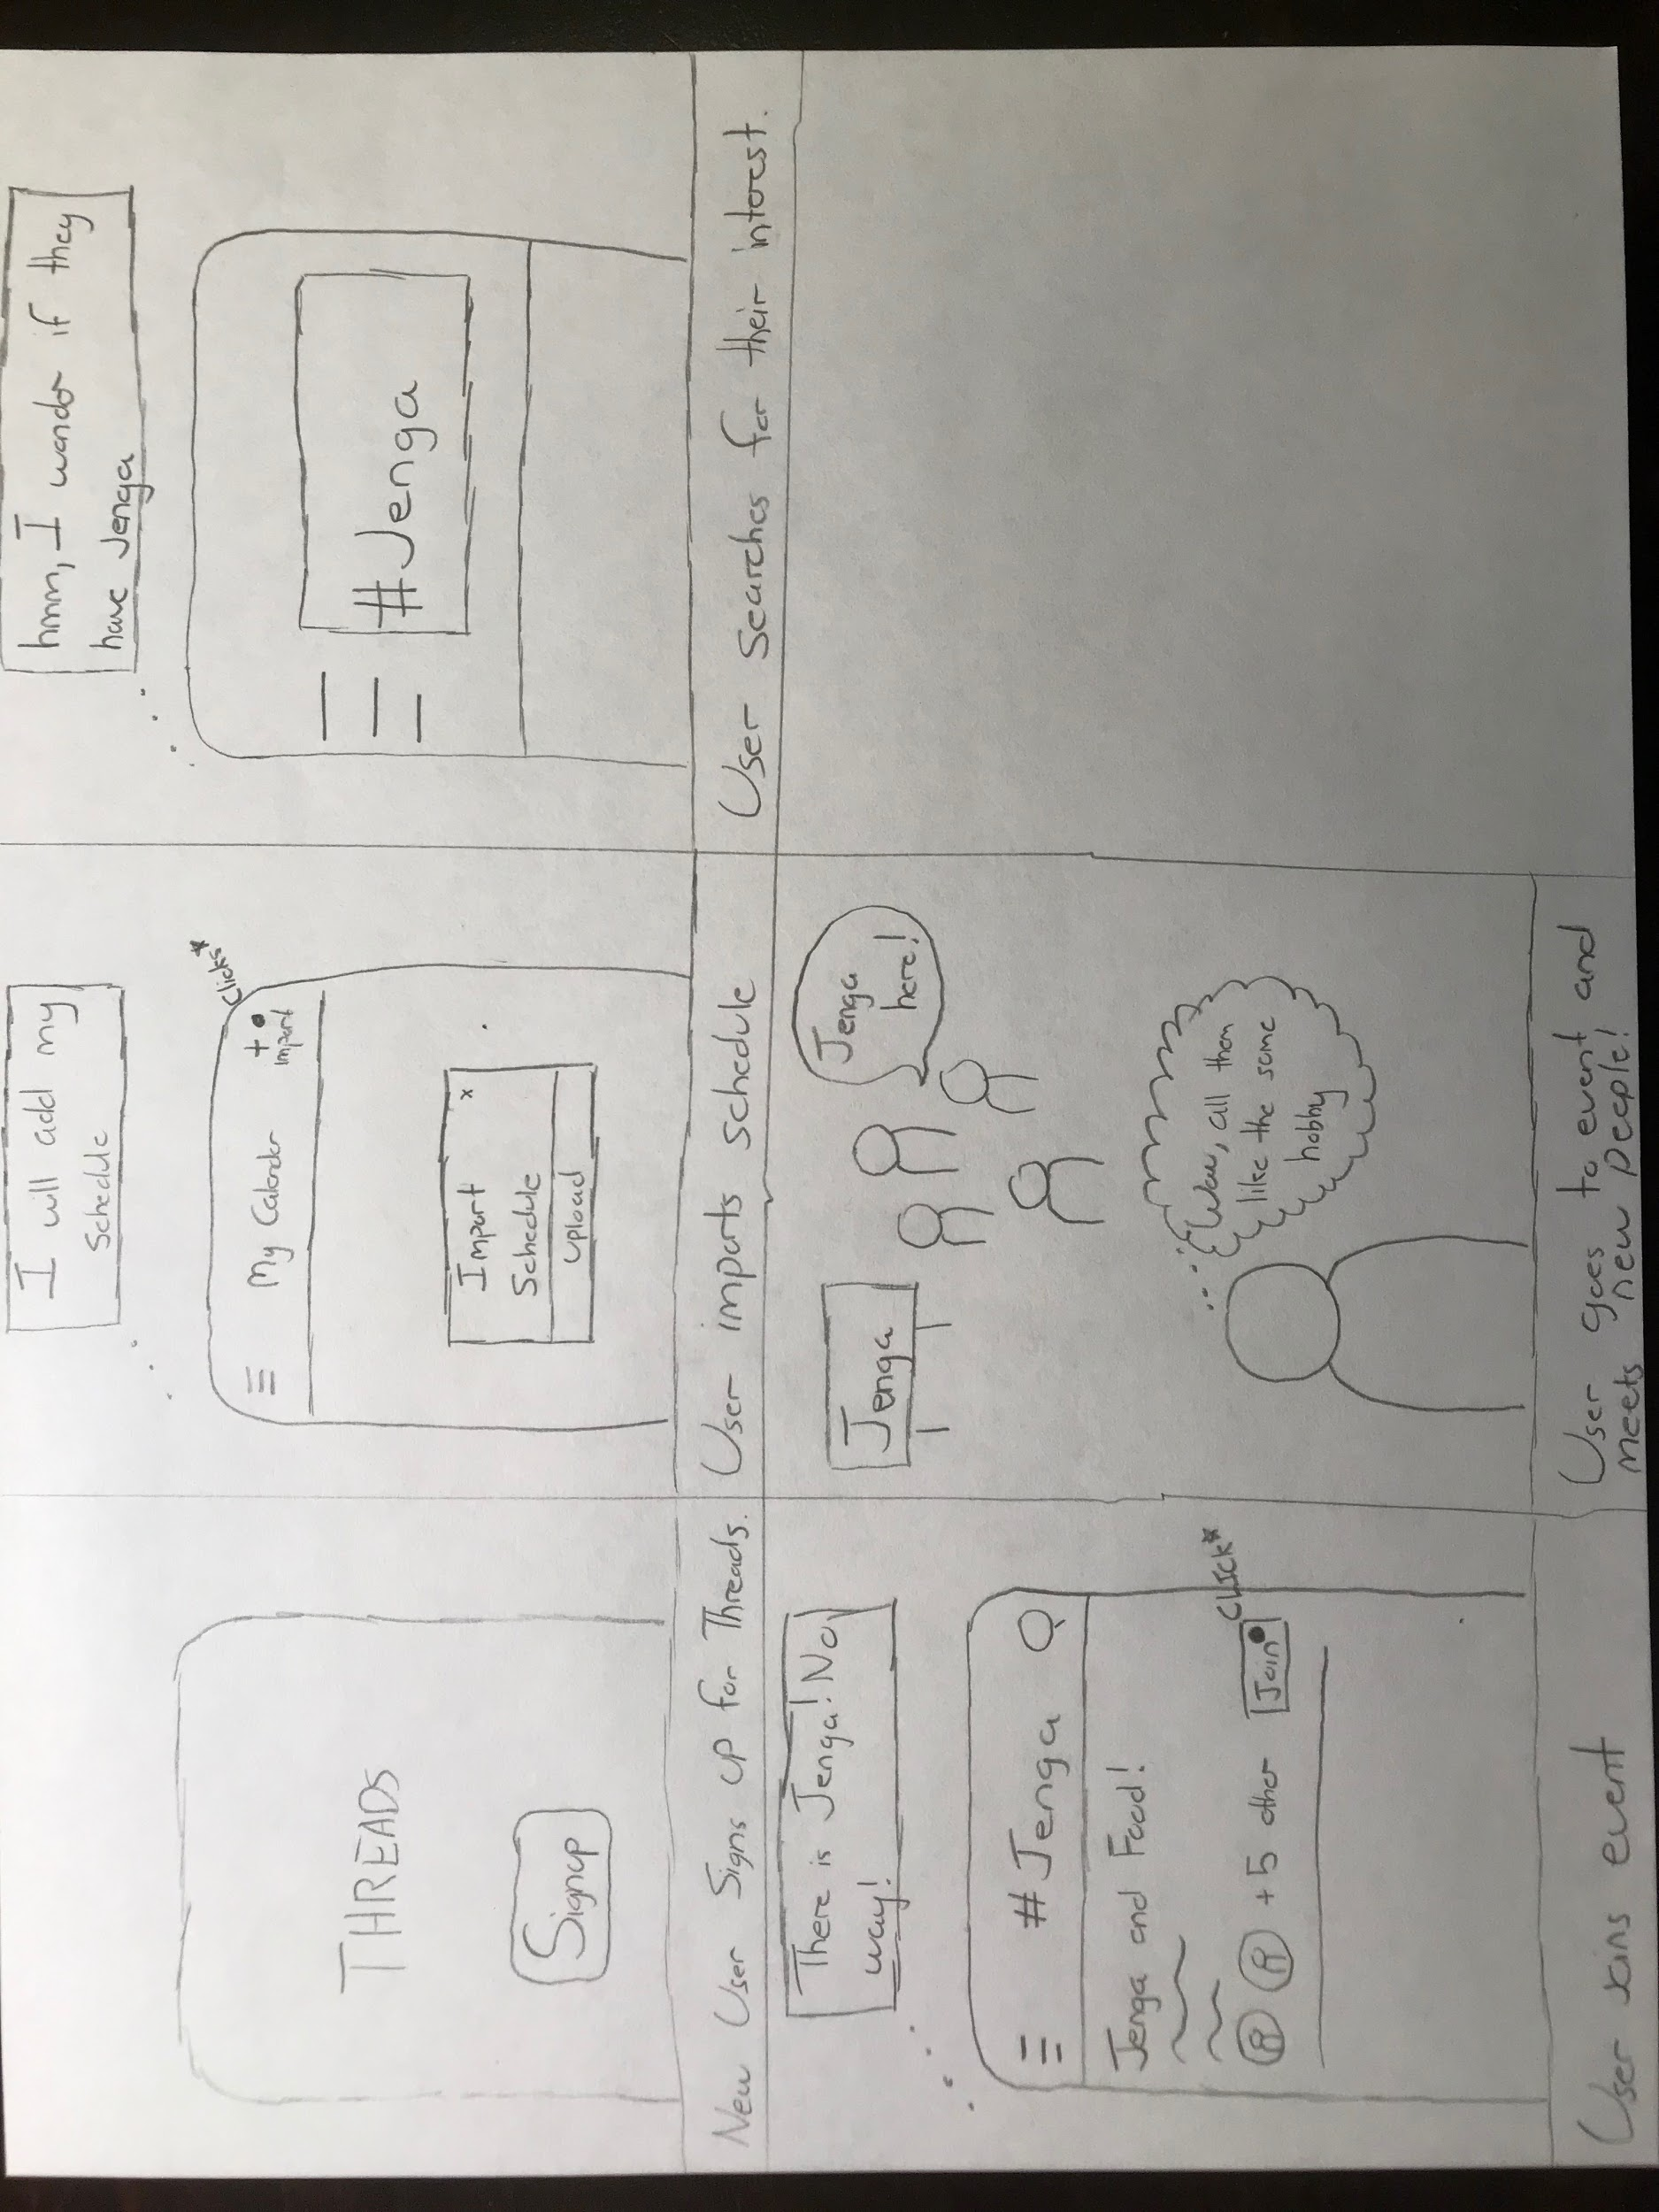

**Application will only focus on creating and joining events**

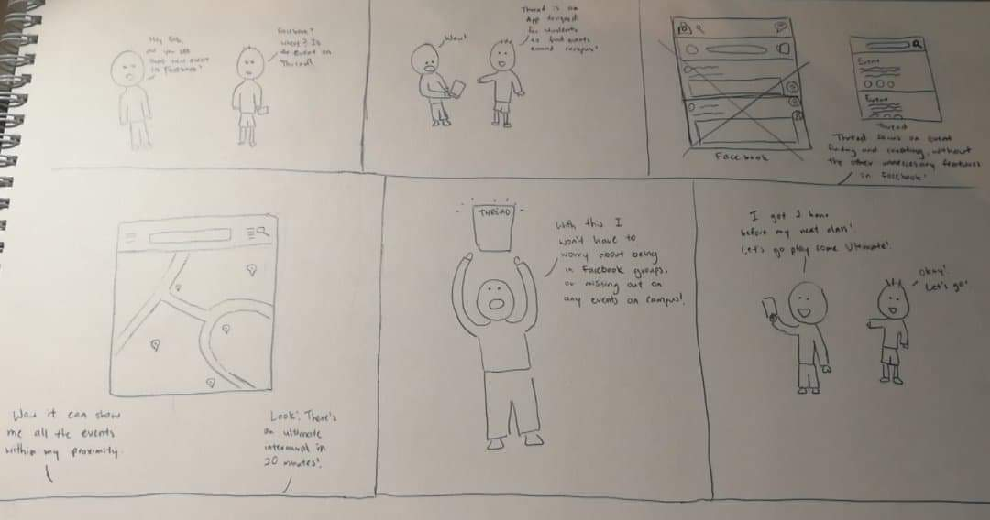

**Application uses Social Media like features (Reward system)**

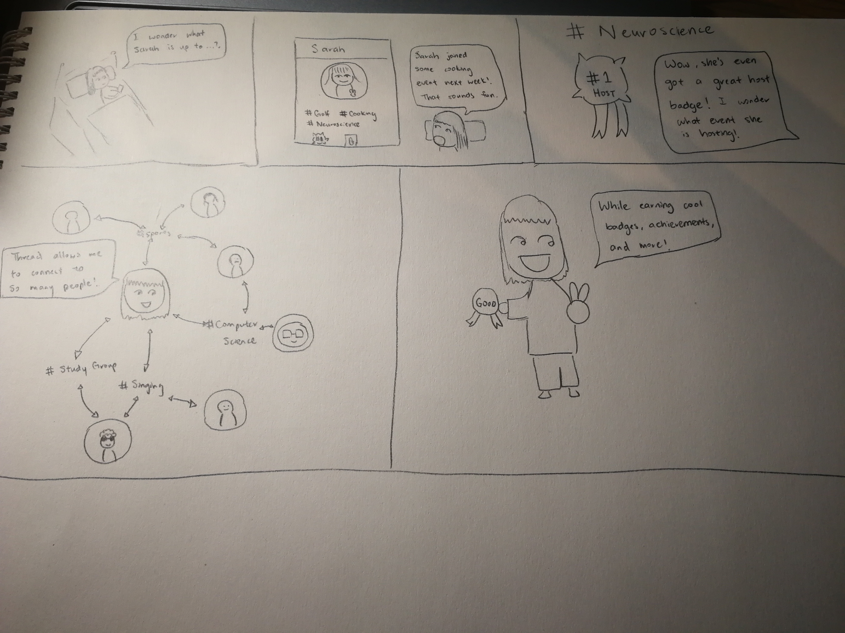

## **Low-Fidelity Prototype - Evaluations**

### **Heuristic Evaluations**

The protocol for our testing can be found via:

*https://drive.google.com/drive/folders/1ryF3Y_yG2ruFQtegTo6_90bbCwKT7xPc*

For our usability testings, we were able to test our prototype on 8 participants who were students at University of Toronto. With each testing taking 25 minutes, we broke it down to 4 parts; Introduction of concept, brief demonstration, user task, and questions/answers. We decided to use a heuristic evaluation to see if our user interface had any pain points or areas where it may result in confusion. The evaluation and experts will let us know which principle needs to be worked on, so our final product can be further refined.

Within our 8 heuristic evaluations, they were common patterns that were pointed out by the experts. It was noted by each expert that there were little to no help or documentation for the different views and app in general. Out of the box, the application will need context to understand certain features and functionalities. A common problem where this was indicated was the list-view icon. This icon will not always be intuitive for every user, previous experience with different apps is why they understood the icon in our product. From this, we look to add a help button that will help display definition of icons, and functions throughout the application.

The majority of the experts agreed upon how our navigation was laid out. In terms of the sidebar menu is global and can access different pages from any view. As well how the map and list view are interchangeable. On similar note, we found that the experts were confused with the home page (My calendar). It was noted that My Calendar would assume there is a calendar or an option for calendar. The experts found this misleading and found that “My Calendar” is not really a calendar but a feed of the users event.

The experts also noted that on the homepage if there is an empty calendar, there is no intuition on what to do next. It is up to the users to find out they have to then search for an event, and then it will be automatically updated on their My Calendar depending if they joined the event or not. It was suggested to add a prompt/alert or light text to help lead the users towards what step should be taken next.

The last pattern between the experts analysis before general comments of the product is system visibility and error prevention. There were no success messages for creating an event besides a badge showing up, or if the user did not fill out the entirety of forms. Joining events had no confirmation, what happens if users join events by accident and do not notice. There should be more visibility in terms of what action is being done. Look to incorporate more feedback in the form of prompts and alerts that will help users understand what is currently being processed.

A few comments in regard to the designs are implementing a review system for the event. This can help gain reputation for the host but also educate users on whether this event might be for them without sacrificing the time to attend. The thread display of profile page should be revamped. Look to change how to manage subscribed threads, maybe add a liking feature for threads. Then lastly, users should be able to view their own schedule within profile or homepage. The idea of checking conflicts works, but in order to organize and prepare for the future, the user should be able to see their school schedule within the application.

**Think Aloud**

*Please use the link located at the end of the PDF, to view our Think Aloud recordings.*

In the Think Aloud, we look to gain insight on the average user and how they will interact with our product. We look to see what steps they take to do certain functions, what navigation path they choose, and overall thoughts on certain designs throughout the app. This will help us find pain points in our interface design, where we will have to improve on efficiency, or design implementation. For the Think Aloud, we will use the same two tasks we conducted in the heuristic evaluation, and see how it weighs with our targeted user.

While conducting our heuristic evaluations, we got the 8 experts to perform a Think Aloud based on two tasks. One task is as a user, to import your schedule and find and join a computer science event. Where the second task instructed the expert to host a specific event, and return to My Calendar to view the event. Between all 8 testings, each one of the experts were able to complete their assigned task. Based off these testings, their were no interaction issues that caused any errors on completing the task. Each expert were able to finish in an orderly manner, finding no misleading functions to accomplish the task.

## 

## **Lessons learned and implications for designs**

Based on the evaluations of the usability testings (heuristics), we have learned what should be kept and what should be refined for the next iteration of the prototype. I think in terms of overall design of our product, it works and most experts found it simple to navigate through. We learned that there should be a help button to help make certain decisions easier for new and confused users. Though, we thought the My Calendar would work just to show events, it seemed many experts were expecting a calendar. For our next design iteration, we will be looking to add an icon functionality that will allow the users to switch between a calendar and feed view. This lets users control which design layout they prefer, without completely ditching either. We would like to focus on redefining our profile page, making it more interactable for the user. Although, we have not decided what we will add, we will look into creating a more interactive badge system, or classmate/thread relationship system. Besides fine-tuning small fixes like error prevention and alerts, the application will move forward to the next design iteration of high fidelity prototype with the changes listed above.

## **Usability Testing Recordings**

Please follow the link below, you will be able to access our conducted Usability Testings.

<https://drive.google.com/drive/folders/1ryF3Y_yG2ruFQtegTo6_90bbCwKT7xPc>

## **Notes**

Original size images for prototype can be found in the link below:

<https://drive.google.com/drive/folders/1ryF3Y_yG2ruFQtegTo6_90bbCwKT7xPc>

### **Group Management**

|  |  |  |  |
| --- | --- | --- | --- |
| **Member** | **Task** | **Description** | **Time** |
| Parth | Paper prototype, low-fidelity evaluations | Brainstorm and designed prototype layout, conduct heuristic evaluation testing | 5 Hours |
| Allen | Paper prototype, Low-Fidelity - Evaluations, Storyboard | Brainstorm and designed prototype layout, conduct heuristic evaluation testing, draw design requirement storyboards | 6 Hours |
| Clare | Summary, Paper Prototype | Brainstorm and designed prototype layout | 2 Hours |
| Pascal | Summary, Paper Prototype | Brainstorm and designed prototype layout | 2 Hours |
| Patrick | Summary, Design Alternatives, Paper Prototype, Storyboard, Low-Fidelity - Evaluations, Lessons Learned | Brainstorm and created paper prototype, conduct heuristic evaluation testing, draw design requirement storyboards, summarize paper, summarize lessons learned | 8 Hours |